DRESS CODE – UNIFORMS

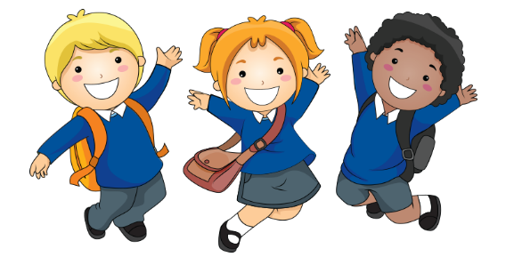

Approved Shirts:
- Polos in Red, White, Grey
- Richland T-Shirts (capital campaign shirts and spirit-wear shirts sold by McNeil Graphics)
- Monogrammed/Applique' (raised stitching) shirts in red, white, grey with R or Richland Only and may only use Richland Uniform colors: red, white, grey, black, or navy in monogram/applique' fabric and stitching

Shirts that are Not Allowed:
- No Vinyl (sticker-like) Shirts, Including Richland or R fonts, Minecraft & Star Wars fonts
- Monograms/Appliques that Include pictures- school buses, apples.. etc.

Allowed Dresses:
- Polo dresses in red, white, or grey only
- Monogrammed/Applique/ (raised stitching) dresses in red, white, grey, with R or Richland Only and may only use Richland uniform colors: red, white, grey, black, or navy in monogram/applique' fabric and stitching
- Jumpers In khaki, navy, and black with a red, white, or grey collared shirt underneath

Allowed Bottoms:
- Pants, Skirts/Skorts, & Shorts (to knees) in solid colors: khaki, navy, and black.
- Jeans are only permitted on Fridays for students who had zero tardies/absences for the week and for special occasions designated by the principal
- Leggings may not be worn as pants. They may be worn under a dress, jumper, or skirt only and must be solid black, navy, or khaki.

Allowed Jackets/Sweaters/Sweatshirts:
- Solid Richland colors (red, black, white, grey, navy, and Khaki)
- No writing, logos, teams, except for Richland or R
- Heavy coats should not be worn during times other than arrival, recess, and dismissal.

Shoes:
- Shoes must have a strap on the back
- Crocs are not allowed
- Shoes must not have more than a one-inch heel

Violation of the dress code will result in parents being called to bring the appropriate clothing to school and consequences ranging from parent conferences to loss of privileges.

